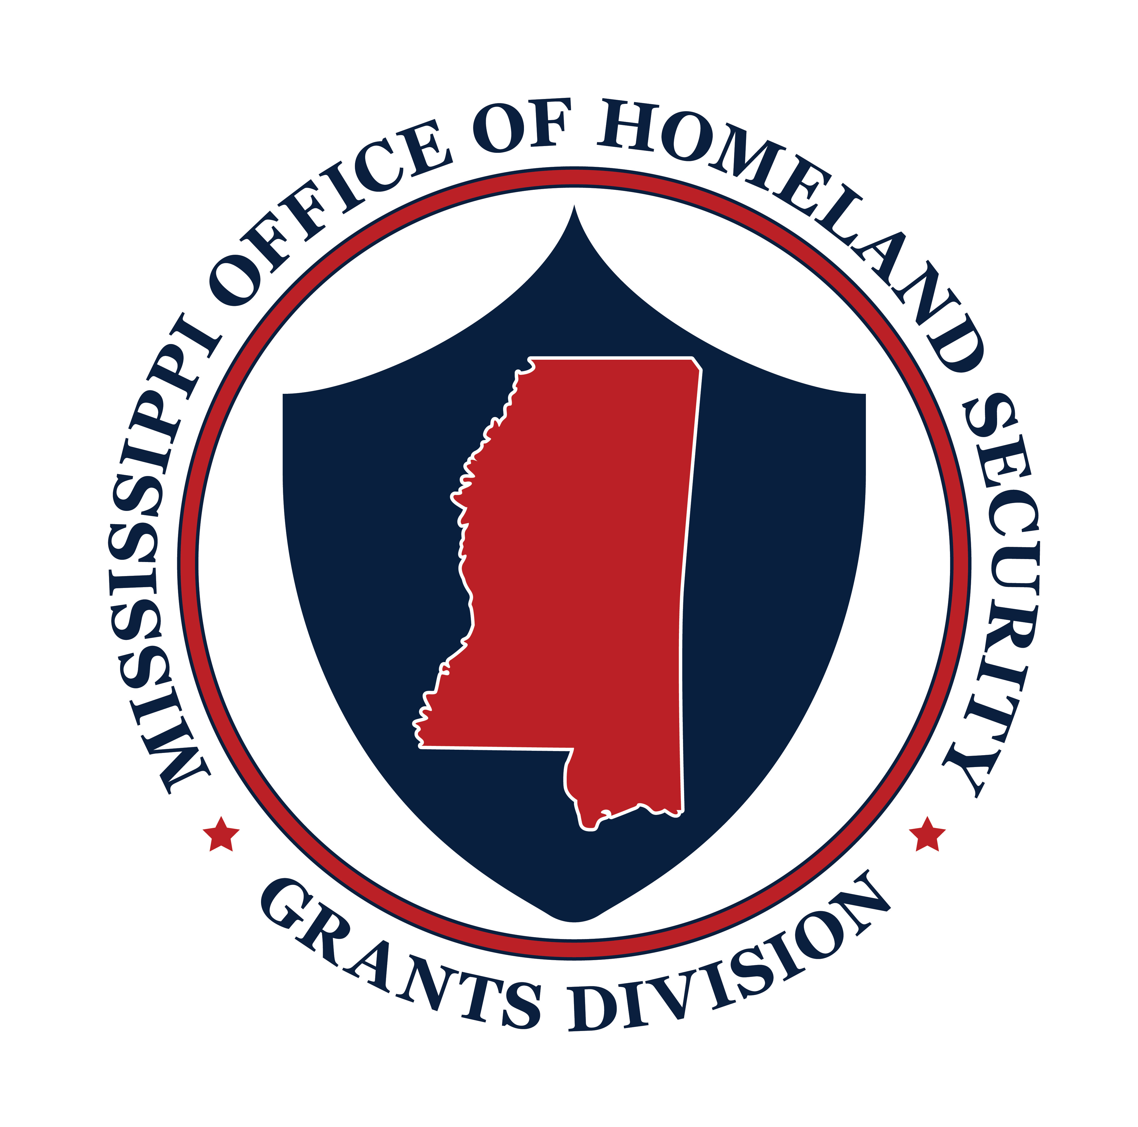

Homeland Security

FY22 State and Local Cybersecurity Grant Program

Orientation Acknowledgment Form

By signing this Orientation Acknowledgment form, I acknowledge that I have received and viewed a copy of the FY22 Mississippi Office of Homeland Security (MOHS)-State and Local Cybersecurity Grant Program (SLCGP) Orientation documents.

I understand and agree that it is my responsibility to read, understand and follow all the guidance set forth in the grant award and the grant program documents.

I acknowledge that if I have any questions, comments or concerns related to the grant award documents or grant program documents, I am encouraged to discuss matters with MOHS staff and seek guidance and technical assistance.

Date:
Name:
Signature:
Agency Name:
Please return this form to: MOHS Grants: mohsgrants@dps.ms.gov

